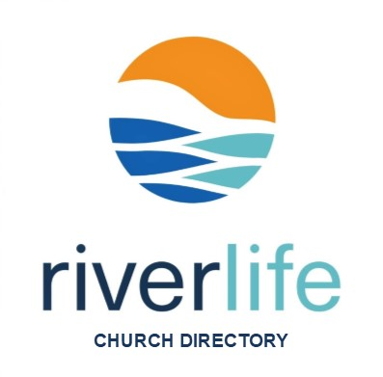
2024 Church Directory Contact Form
If you consider RiverLife Fellowship to be your church home and attend the Mooresville Campus, we welcome you to participate. The purpose of the directory is to put names with faces along with contact information, so we can better connect with our growing church family. [Please complete & return to Paula Stark or Kristen Tiessen]

*1. Family Last Name:

*2. Check One:

I am new to RiverLife and would like to be included in the new directory [complete entire form]
My info has not changed from last year’s edition [fill fields *1-3]
I need to update my info from last year’s edition [fill fields *1-3 and fields that have changed]

I will email an updated photo (.JPEG file or .PNG file) to directory@riverlifefellowship.com
Use my photo from the last RLF Directory
Use a Facebook photo I approve
Other, specify below
Please specify:
*3. Check one - Individual/Family Group Photo:

4. Home Information:

Street Address: |  | Apt. #:
City: | State: | Zip Code:
Home/Landline Phone Number:

5. Individual Household Member Contact Info: (list head(s) of household then children living home in age order)

LAST NAME: | FIRST NAME: | EMAIL: | MOBILE #:
6. Attending Since mm/yyyy: | How did you find us?

