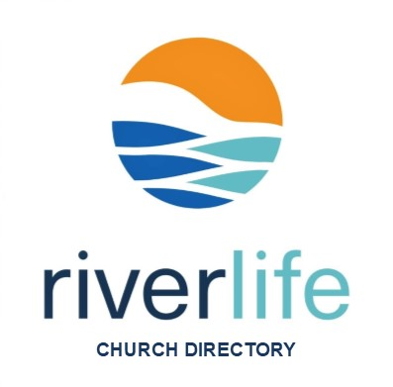
2024 Church Directory Contact Form
If you consider RiverLife Fellowship to be your church home and attend the Mooresville Campus, we welcome you to participate. The purpose of the directory is to put names with faces along with contact information, so we can better connect with our growing church family. [Please complete & return to Paula Stark or Kristen Tiessen]
Type your information in the yellow highlighted areas & check one box for #2 & #3.
*1. Family Last Name:

*2. Check One:

☐ | I am new to RiverLife and would like to be included in the new directory [complete entire form 1-7]
☐ | My info has not changed from last year’s edition [fill fields *1-3]
☐ | I need to update my info from last year’s edition [fill fields *1-3 and fields that have changed]

☐ | I will upload [see #7] or email an updated photo (.JPEG file or .PNG file) to directory@riverlifefellowship.com
☐ | Use my photo from the last RLF Directory
☐ | Use a Facebook photo I approve
☐ | Other, specify below
Please specify:
*3. Check one - Individual/Family Group Photo:

4. Home Information:

Street Address: |  | Apt. #:
City: | State: | Zip Code:
Home/Landline Phone Number: - -

5. Individual Household Member Contact Info: (list head(s) of household then children living home in age order)

LAST NAME: | FIRST NAME: | EMAIL: | MOBILE #:
 |  |  | - -
 |  |  | - -
 |  |  | - -
 |  |  | - -
 |  |  | - -
 |  |  | - -
 |  |  | - -
 |  |  | - -
 |  |  | - -
6. Attending Since mm/yyyy: / | How did you find us?

Please submit photo on next page…

7. Click in the photo box below to upload a jpeg photo of you/family

or

Check this box
☐ I will email an updated photo before April 14th.

To submit:
Once form is completed save a copy then attach file
and email to directory@riverlifefellowship.com.

